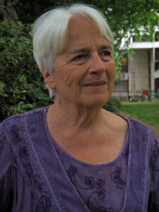

What is prayer?

11 November
Day workshop 10am - 4pm

Led by Jennifer Kavanagh

Many of us have a problem with the word, maybe the whole concept, of prayer. This day workshop gives us the opportunity to share what we feel about it and explore different types of prayer. What is prayer? Who or what do we pray to? Does it work?

This workshop offers a rare opportunity to share something of our spiritual lives and practice.
We will consider how forms of collective and individual prayer in different traditions are reflected in our own spiritual practice, if we have one. We will explore the practice of contemplative prayer and the possibility of an entire life lived as prayer. Is prayer the same as worship?

We will spend the day as a community, with time in plenary, as well as sharing in pairs and groups. There will be input, some readings, and time for solitary consideration. We will also use the Prayer card game as a tool of exploration.

There will an opportunity to buy copies of Jennifer’s forthcoming book, Do Quakers Pray? as well as some of her other books, and the Prayer game (cash or cheque only, please).

For further enquiries about the workshop, email office@jordansquakercentre.org
Also see: https://www.jenniferkavanagh.co.uk/

